Chapter 1: Use Case Notebook for Instructors

Ram Gopal, Dan Philps, and Tillman Weyde

Summer 2022

Table of Contents

# Use case: Descriptive Statistics and Correlations to Determine US Supermarket Sales Strategy

Descriptive statistics and correlations help us understand more about business problems, and can improve our decision making. For instance, a supermarket chain needs to maximize sales at the lowest marketing cost, determining whether in-store promotion or out-of-store advertising is most effective in driving profits by product line. Should they invest more in Promotions or Advertising?

df_supermarket <- read.csv("../../data/50_SupermarketBranches.csv")  
head(df_supermarket)

## Advertisement.Spend Promotion.Spend Administration.Spend State Profit  
## 1 165349 136898 471784 New York 192262  
## 2 162598 151378 443899 California 191792  
## 3 153442 101146 407935 Florida 191050  
## 4 144372 118672 383200 New York 182902  
## 5 142107 91392 366168 Florida 166188  
## 6 131877 99815 362861 New York 156991

print(summary(df_supermarket))

## Advertisement.Spend Promotion.Spend Administration.Spend State   
## Min. : 0 Min. : 51283 Min. : 0 Length:50   
## 1st Qu.: 39936 1st Qu.:103731 1st Qu.:129300 Class :character   
## Median : 73051 Median :122700 Median :212716 Mode :character   
## Mean : 73722 Mean :121345 Mean :211025   
## 3rd Qu.:101603 3rd Qu.:144842 3rd Qu.:299469   
## Max. :165349 Max. :182646 Max. :471784   
## Profit   
## Min. : 14681   
## 1st Qu.: 90139   
## Median :107978   
## Mean :112013   
## 3rd Qu.:139766   
## Max. :192262

There are several interesting points to note about our marketing approach we can see from the descriptive statistics immediately. The range of spend on Advertising ($0 to $ 165,349) is wider than on Promotion ($51,283 to $182,645) across product lines, in some cases nothing is spent on advertising. All lines are promoted, not all are advertised. Mean promotion spend ($121,344) is considerably more than mean advertising spend ($73,721).

Now we can examine the correlations between Advertising Spend and Profits and Promotion Spend and Profits. We can use charts to examine the correlations. If there is no relationship, we will see a cloud of dots with no form:

plot(df_supermarket$Promotion.Spend,df_supermarket$Profit,  
 main = 'Relationship between Promotion Spend and profit   
 (each point is a product line)',  
 xlab = 'Promotion Spend',  
 ylab = 'Profit')

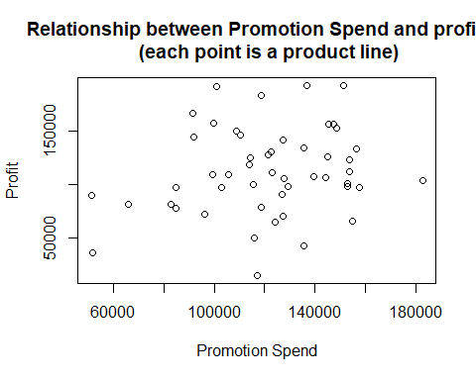

There is no apparent relationship between Promotion Spend and Profits. In this case it appears that every extra dollar we spend on Promoting a product line does not contribute to profits from that line. We now examine Advertisement Spend:

plot(df_supermarket$Advertisement.Spend,df_supermarket$Profit,  
 main = 'Relationship between Advertisement Spend and profit   
 (each point is a product line)',  
 xlab = 'Advertisement Spend',  
 ylab = 'Profit')

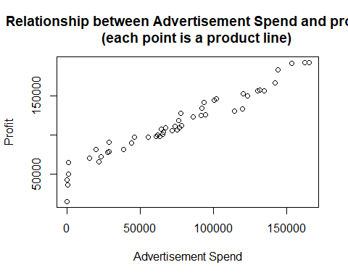

Advertisement Spend is quite different and shows a strong relationship between profits and out-of-store advertising spending. The dots follow an upwards sloping line, described as a linear relationship with a positive slope. This means that with every product line where more has been spent on advertising, more profit has resulted. Where less has been spent on advertising less profit has resulted. The amount of US $sinprofitwegainfromandextra1US$ spent on advertising is described by the slope of the line. We can now calculate the correlation coefficients.

cor(df_supermarket$Profit,df_supermarket[-c(4,5)])

## Advertisement.Spend Promotion.Spend Administration.Spend  
## [1,] 0.9729 0.2007 0.7478

The correlation coefficients show what we already know, that Advertisement Spend has a high correlation (0.97), while Promotion Spend has a low correlation (0.20). While correlation is not necessarily causation, from this analysis we can clearly see that Advertising has the stronger relationship with profits. It would make sense to review possible increases in Advertising spend by product line as a priority, and to review reductions in promotion spending too.